

CD4 COMMODITY

**USER GUIDE AND DOCUMENTATION**

**©Nacp 2014**

Contents

Dash board 1

Downloading Charts 2

Date Filters 2

Chart Filters 2

Regional drilldown 3

Functionality 4

Reporting Cycle 5

Functionality 5

Functionality 6

Reports 6

CD4 Tests 7

Equipment 7

POC Devices Errors 8

Change Password 9

NACP

**When the nacp module is loaded the dash board is the first page to load, the menu on the menu bar that is bold. At the top left corner of the page shows the current date, next to it is the name of the current logged in user followed by a search text field.**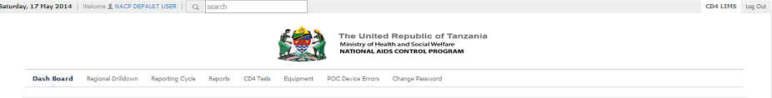

**At the top right corner is an option to logout and next to it is a CD4 LIM option that directs the user to the homepage where the national data can be viewed**

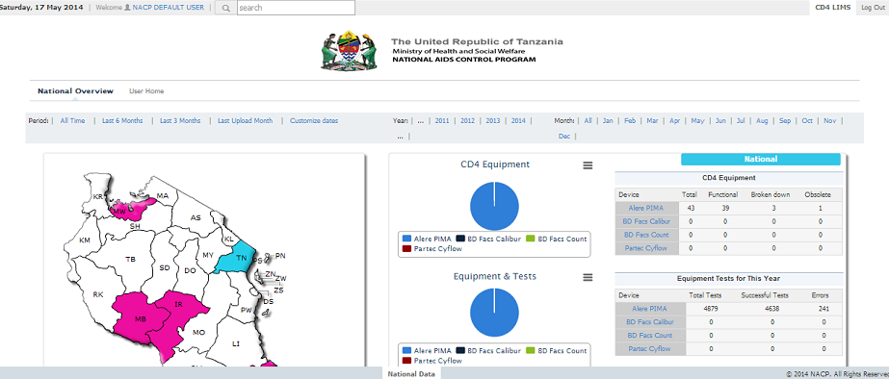

**This NACP module has a menu bar that has a number of options that include: Dash board, Regional Drill, Reporting Cycle, Reports, CD4 Tests, Equipment, POC Device Errors and Change Password.**

# ****Dash board****

**By default when the dash board is loaded, the PIMA tab is also opened.** **The first graph to the left shows the testing trends that have been observed for the last 4 years. The graph shows the number of tests that were above critical and those that were below critical. The bar graph next to it is a graph of device tests that have been conducted on a yearly basis.** **On the lower left side of the page there is a panel that shows equipment and equipment and test. On the right side of the page is another panel that the PIMA tests. It shows the total number of tests that were attempted, the number of valid tests, those that were above the critical level(350 cells/mm for adults) together with those that were below critical(25% for pediatrics) and the number of unsuccessful tests.**

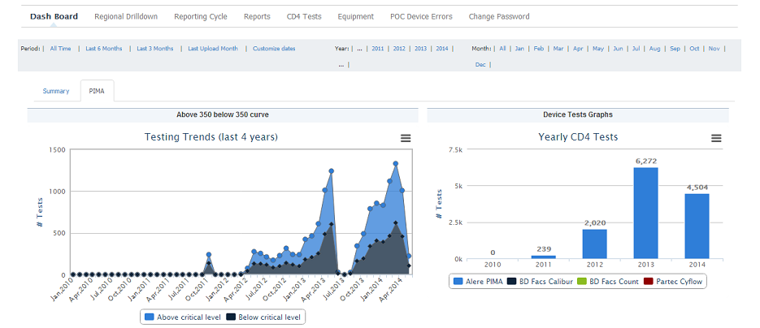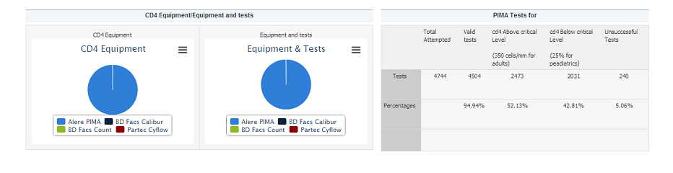

**B**

**A**

## **Downloading Charts**

**The icon labeled *‘A’* above will enable the user to download the chart as an image. Available download formats include, jpeg, png images and pdf documents.**

**Filtering Information**

### **Date Filters**

**Most pages in the NACP module have a date filter right at the top. This date filter is divided, starting from the right into, grouped dates which eventually narrow down to more specific dates. By clicking on either of the links, .i.e. the line of words starting *‘period’*, you will be able to narrow down the figures displayed on the webpage to a specific month.**

### **Chart Filters**

**Charts are accompanied with a key as labeled above, *‘B’.* Clicking on the keys will disable that specific element on the chart while leaving the remaining elements visible.**

#### **Example**

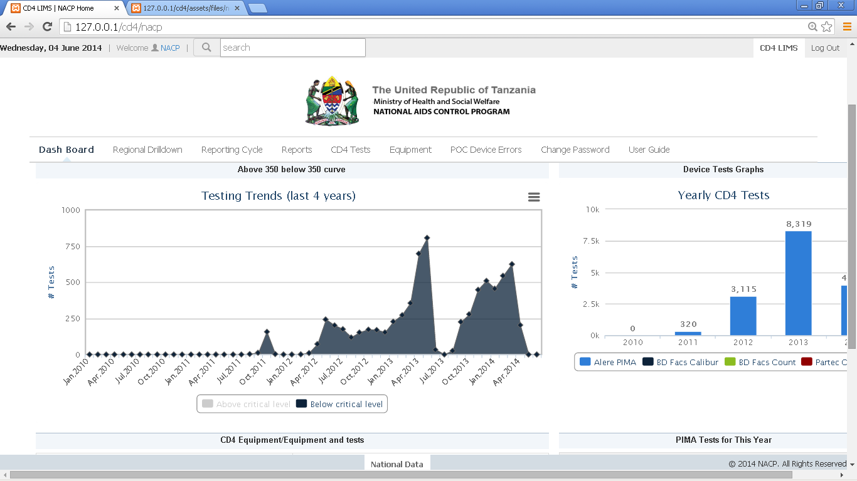

**The above testing trends display information for below the critical level only as the above critical level has been disabled.**

# **Regional drilldown**

**The left most table shows the regions that are the in the country. The table (CD4 Tests for this year) on the right shows the tests results of the tests that have been conducted in the entire current year. This table shows the number of total attempted test, the number of the valid tests, the tests that came out as above the critical level (350 cells/mm for adults), the tests that were below the critical level (25% for pediatrics) and the number of unsuccessful tests. Below the CD4 Tests table there is an Equipment Test table that shows the number of tests the available equipments have been used to conduct, this include the total number of tests, number of the successful tests and the number of errors encountered.** 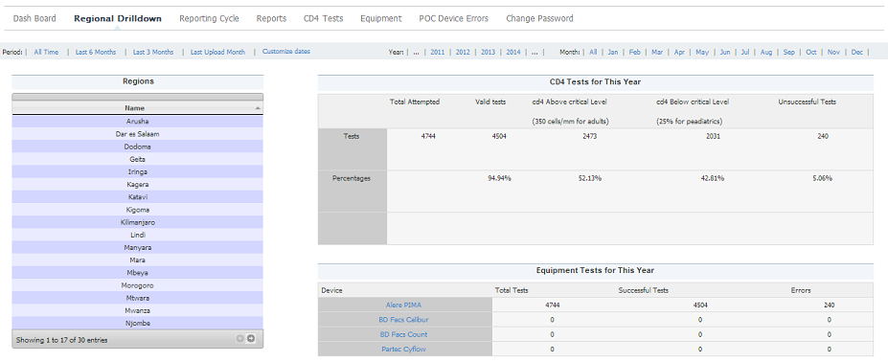

**The lower table shows the CD4 tests, the dates that the tests have been conducted, the number of facilities that have been reported, the number of total tests that that were conducted in the specified period of time, the number of valid test that have been conducted in that period of time, the number of tests that were above the critical level and the number of tests that were below the critical limit.**

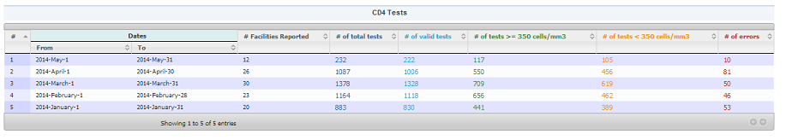

## **Functionality**

**The regional drilldown page enables the user to get reports from a regional level up to the facility level at the click of a button.**

**By default the page will have the ALL the regions displayed on the column on the left hand side. The other three tables are dependent on what has been click on this first table. By default the other three tables display information at a national level.**

**By clicking on one of the regions on the column on the first hand side, the page will refresh. The new page will contain all the districts in that region on the column on the left hand side, while the other three tables will be populated with information regarding the region clicked.**

**This kind of drilldown goes down up to the facility level. Again the date filters can be called upon to narrow down the search field.**

# **Reporting Cycle**

**On the left side of the page there is a map of the country showing the various regions in the country. On the right side is a section showing the facilities that have reported and below that those that have not yet reported below together with the regions the facilities belong to.**

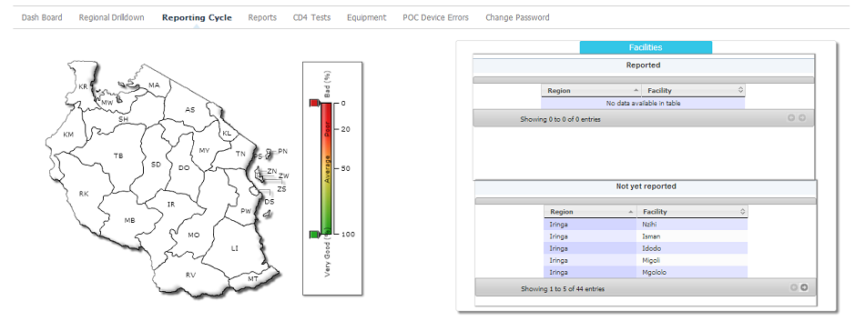

## **Functionality**

**This page gives an overview of the general reporting progress of the entire nation.**

**The map to the top right of the page is segmented according to the various regions in Tanzania. Along-side the map is a key associated with it. This key has a scale that ranges between 0% - 100%.**

**0% represents zero reporting from the various facilities. This situation is color coded by the color red. 100% represents excellent reporting by the facilities and this is associated with the color green. The exact figures for the color coding are,**

* **0% - 33% - very poor reporting**
* **34% - 60% - fair reporting**
* **61% - 100% - excellent reporting**

**The tables to the right of the map then give more details regarding which facilities from which regions have reported.**

**On the lower part of the page is a timeline showing the reporting timeline for the devices as shown in the figure below in this case the timeline is a month. Below the timeline is a line graph that shows the number of expected reporting devices and the actual number of reported devices.**

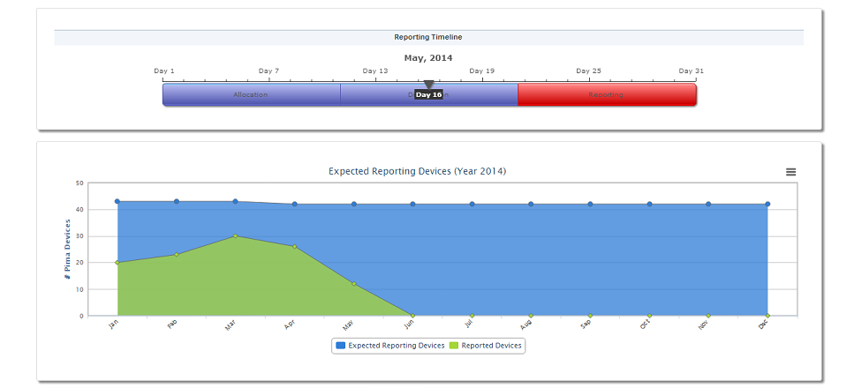

## **Functionality**

**The reporting timeline is basically a reminder to the user of the system when it is time to follow up on the reporting of the facilities. The timeline is divided into three sections, allocation, and distribution and reporting. These are three major stages involved in CD4 testing. This page is only interested in the last section, the reporting phase.**

**The last section will change color depending on the reporting percentages. The color coding is similar to that used in the Tanzania map. This has been explained just above this. The timeline has an arrow that displays the progress along the line as well as the current day of the month.**

**The chart on expected reporting devices can easily be downloaded as a jpeg image, png image or as a pdf document. The key at the bottom of the page allows the user to hide either of the elements that particular chart.**

# **Reports**

**Generation of reports is solely dependent on what the user wants to see. The reports page is split into three ‘*columns’.* The first column defines what kind of report you want. This is done by selecting different options on the dropdown boxes provided. By default this section is compressed to just three drop down boxes, depending on your selection more drop down boxes will show up.**

**The middle column allows you to determine the format in which you want your report in, either pdf or excel spread-sheet. Hit download report to begin the download after properly selecting your fields on the first column described above. Reset will simply reset the first column to the default so you can easily generate a second report.**

**The final column is titled notifications; this will prompt the user of any unreported facilities and errors.**

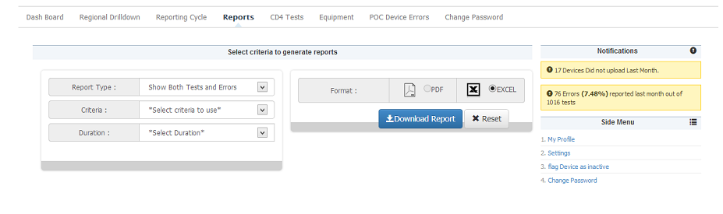

# **CD4 Tests**

**In this section there is a CD4 tests table that consists of the dates when the tests were conducted to the date they ended in this case it’s a month. It also consists of the number of facilities that were reported, the number of total tests, the number of valid tests, the number of tests that were above 350 cells/mm3, number of tests that were below 350 cells/mm3 and the number of errors. The section on the top left allows the administrator to view the equipments in groups of 10, 25, or 100. The user can also search for a facility using the search section on the top right most corner of the table**

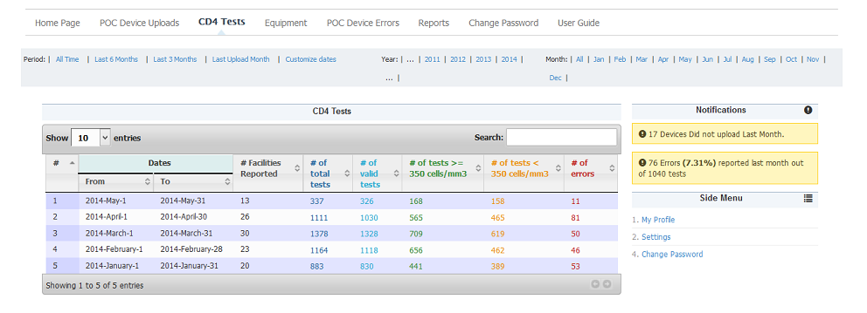

# **Equipment**

**This section shows facilities with equipment. It shows which facility added that equipment, whether it was removed, any reason for deactivation and that particular equipment’s history which is a link that can be followed to view more details on that device. The user can also flag a device as active or inactive. The last column in the table is a link that allows the user to view more details about equipment errors. The section on the top left allows the user to view the facilities in groups of 10, 25, or 100. The user can also search for a facility using the search section on the top right most corner of the table.**

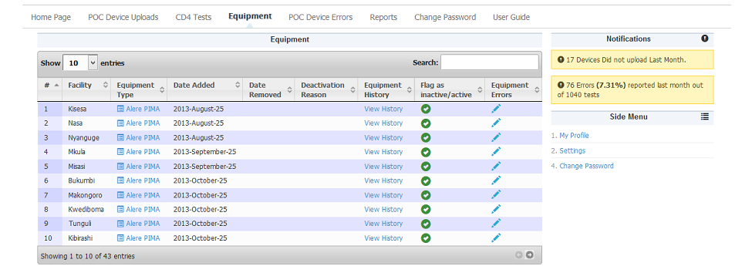

# **POC Devices Errors**

**This section allows shows all the POC Device errors that have been reported. By default the error trends nation-wide is loaded first.**

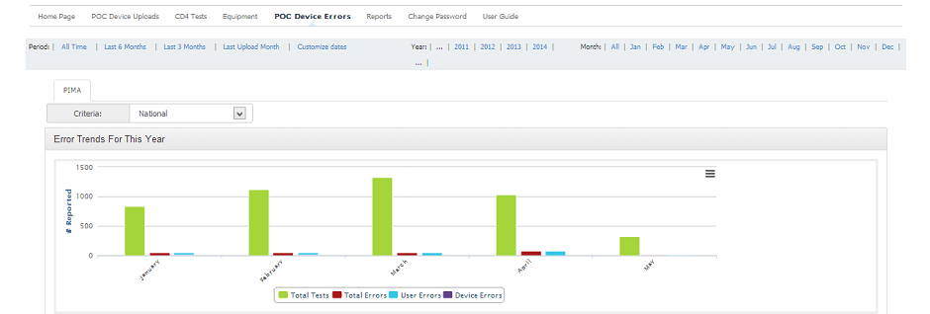

**The graph shows Total Tests done, Total Errors, User Errors, Device Errors for the year 2013**

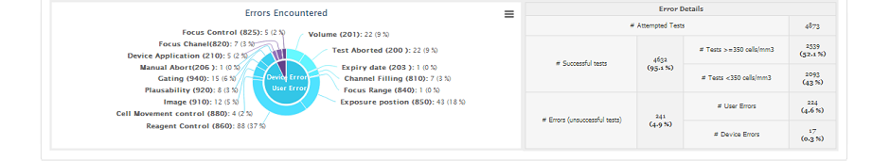

**The above graph shows a detailed overview in a pictorial format of all the components to be considered that make a testing scenario. It is downloadable as PDF or image format by clicking on the icon on the top right corner. The table on the right shows successful tests > = 350 cells/mm3 and test < = 350cells/mm3 and an overall success percentage on tests. The lower section of the report shows the errors encountered both user and device errors in their percentage and an overall error percentage.**

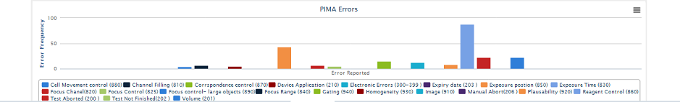

**This graph shows all the PIMA errors and their conditions that lead to the errors. The conditions are represented in a colorful key to easily identify the conditions.**

**By clicking on the criteria combo box, the user can filter the view, by partner, by region, by district, by facility or by device. Another combo box will appear allowing the user to filter by preferred criteria**



# **Change Password**

When the administrator selects the change password menu, he/she is brought to pop-up page that requires the old password, the new password that the administrator intends to be using and then retyping of the new password to ensure that the submitted password is as intended. Once the password is changed the old password becomes obsolete and would not work again unless the password is changed back to the old one.

